COMPUTER NETWORK PRACTICUM REPORT
RJ45 CABLE ASSEMBLY


Lecturer:
Dimas Novian Aditia Syahputra, S. Tr. T., M. Tr. T.
Prepared by:
Name: Aisyah Currents
NIM (Student id): 25091397108
Class: International

UNIVERSITAS NEGERI SURABAYA
FACULTY OF VOCATION
INFORMATICS MANAGEMENT STUDY PROGRAM
YEAR 2025

EQUIPMENT
- UTP Cable
- RJ45 Connector
- Cable Cutter
- Crimping Pliers
- UTP cable tester
PRACTICUM REPORT
TESTING
- Write down the test result using the UTP cable tester
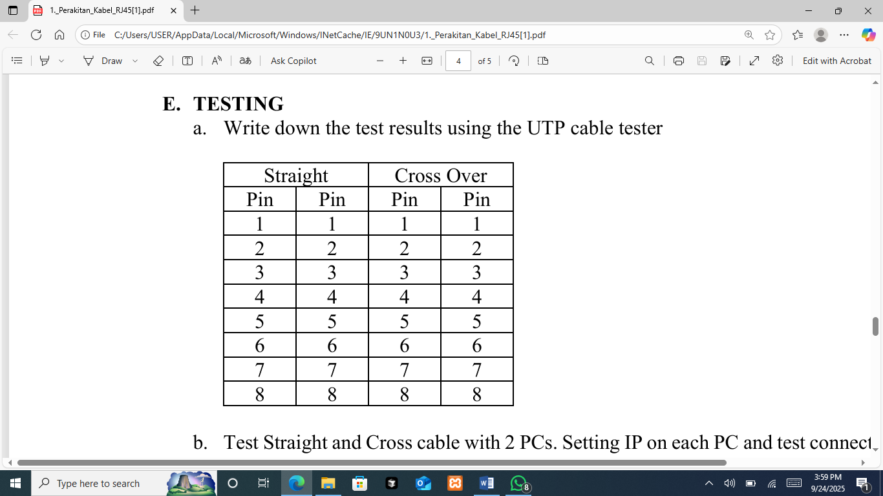
- Test Straight and Cross cable with 2 PCs. Setting IP on each PC and test connection
- Ifconfig
To set the IP address on a PC.
Example:
On PC1 use IP 192.168.1.1
#ifconfig eth0 192.168.1.1 netmask 255.255.255.0
On PC2 use IP 192.168.1.2
#ifconfig eth0 192.168.1.2 netmask 255.255.255.0
- Ping: Test the connection between the 2 PCs (in this example from PC1 to PC2)
debianGUI:~# ping 192.168.1.2
PING 192.168.1.2 (192.168.1.2) 56(84) bytes of data.
64 bytes from 192.168.1.2: icmp_seq=1 ttl=64 time=15.5 ms
64 bytes from 192.168.1.2: icmp_seq=1 ttl=64 time=0.655 ms
64 bytes from 192.168.1.2: icmp_seq=1 ttl=64 time=0.412 ms ^C
--- 192.16.1.2 ping statistics ---
3 packets transmitted, 3 received, 0% packet loss, time 2005ms
Rtt min/avg/max/mdev = 0.412/5.530/15.524/7.067 ms
To stop press Ctrl + C.
If the output is as above, it means your connection was successful.
- Cross Cable Testing
- Setting each PC with point b.
- Use a cross cable, record the results.
- Replace using straight cable, note the results
- Straight Cable Testing
- Setting each PC with point b.
- Use a cross cable, record the results.
- Replace using straight cable, note the results

